DM LAB LA
Clustering

Code:-

#include<bits/stdc++.h>
using namespace std;

void gini(vector<string> a,vector<string> c)
{
int flag=0;
vector<pair<string,int>> b;

for ( int i =0;i<a.size();i++)
{
flag=0;
for (int j=0;j<b.size();j++)
{

if (a[i]==b[j].first)
{
b[j].second++;
flag=1;
}

}
if(flag!=1)
{

b.push_back(make_pair(a[i],1));
}

}
double total=0;
for(int i =0;i<b.size();i++)
{
total = total + b[i].second;
}

double arr[b.size()]={0};
for (int i =0;i<a.size();i++)
{
for (int j=0;j<b.size();j++)
{
if ( a[i]==b[j].first&&c[i]=="Y")
{
arr[j]++;
}
}
}

double gini =0;
double sum =0;

for (int i =0;i<b.size();i++)
{
double temp =(b[i].second/total)*(1 - ((arr[i]*arr[i])/(b[i].second*b[i].second)+((b[i].second-arr[i])*(b[i].second-arr[i]))/(b[i].second*b[i].second)));
sum = sum + temp;
}
cout<<"yes case: "<<arr[0]<<endl<<"no case: "<<arr[1]<<endl;
cout<<sum;
}

int main()
{

fstream fin;
fin.open("input.csv");

vector<string> row,row2;
string line, word, temp;

int i =0;
while (fin.peek() != EOF)
{
getline(fin, line);
stringstream s(line);
while (getline(s, word, ','))
{
row.push_back(word);
}
row.push_back("eol");

}

int cols=0;
for (int j =0;j<row.size();j++)
{
if (row[j]=="eol")
break;

cols++;
}

vector<vector<string>> input;

for (int i =0;i<cols;i++)
{
vector<string> temp={};
input.push_back(temp);
}

for (int i =cols+1;i<row.size();i=i+(cols+1))
{
for (int j = 0; j < cols; j++)
{
input[j].push_back(row[i+j]);
}
}

for (int i =1;i<cols-1;i++){

cout<<"gini of "<<row[i]<<": ";
gini(input[i],input[cols-1]);
cout<<endl;

}
return 0;
}

CSV files:-

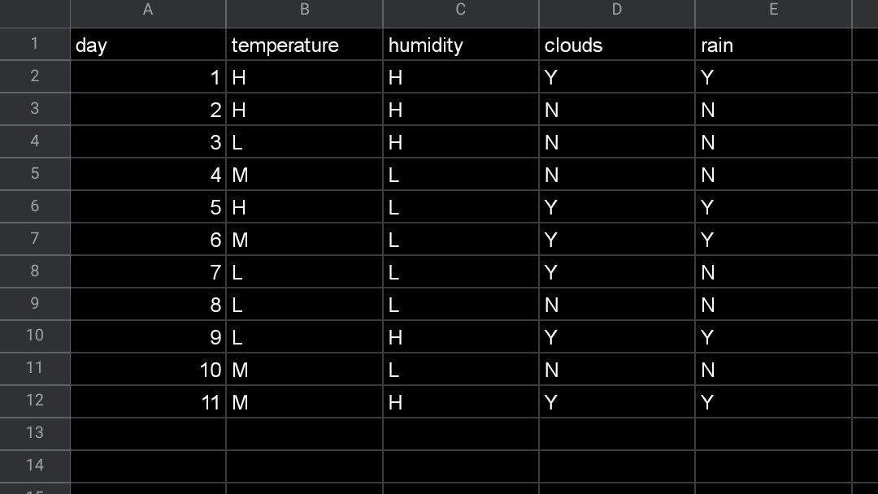

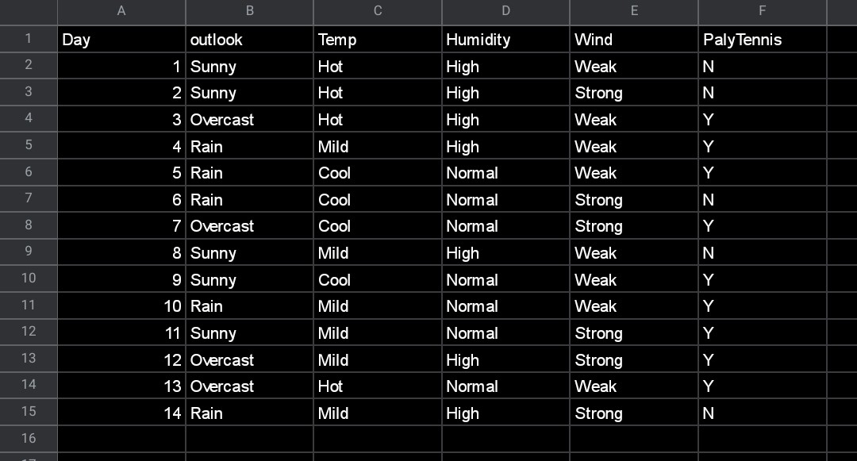

Output:-

